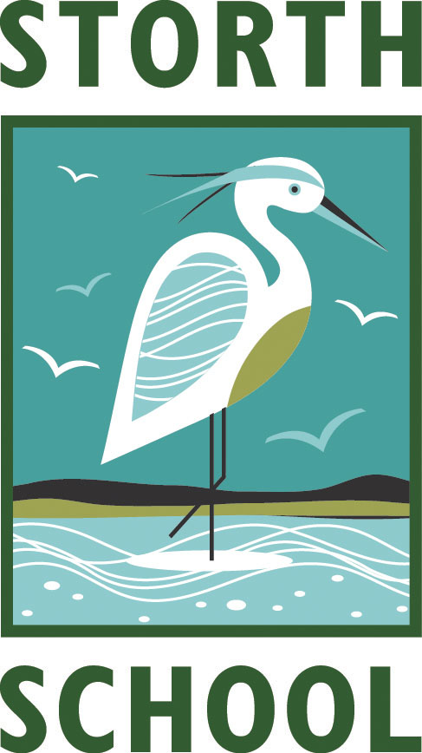
STORTH C. E. PRIMARY SCHOOL

STORTH, MILNTHORPE, CUMBRIA. LA7 7JA

Telephone 015395 62517
Head Teacher: Mr Simon Brabant BA Hons
e-mail: head@storth.cumbria.sch.uk
website: www.storth.cumbria.sch.uk

27th March 2024
Dear Parents/Carers,

Ford Castle Adventure

All of the children in Key Stage 2 will have the opportunity of attending this year’s summer residential at Ford Castle, Berwick-Upon-Tweed. This week-long fun-packed and immensely educational opportunity runs from Monday 10th June until Friday 14th June 2024. The children will be staying at Ford Castle, an old castle converted into a children’s adventure centre. If you would like to see what it has to offer then please go to: https://schoolsandgroups.pgl.co.uk/centres/ford-castle/

The children will have all accommodation provided, a very large breakfast, a packed or hot lunch, and a three-course evening dinner interspersed with snacks and drinks. The dormitories are very spacious and there is a common room for relaxing with a pool table and other games plus a football pitch!

Some of the proposed activities will probably include:
Assault course
Crate stacking
High ropes
Knights quest
Nightline
Zip wire
Canoeing
Time at the beach for games and eco trailing
A trip to Lindisfarne
A boat tour around the Farne Islands
Bamburgh Castle
Places are limited! If your child/ren would like to attend, then please fill in the form below and send a NON-REFUNDABLE deposit of £50 in to the office by April 30th. More details will follow after the Easter break.

If you have any questions or concerns about this trip then please feel free to contact me or see me at any time.

With very best wishes,

Simon Brabant

I would like my child/ren____________________________ to attend Ford Castle Adventure, Berwick-Upon-Tweed Residential from June 10th – 14th 2024.
I will BACS/pay my non-refundable deposit of £50 by April 30th.

Signed _________________________ (parent/guardian)

