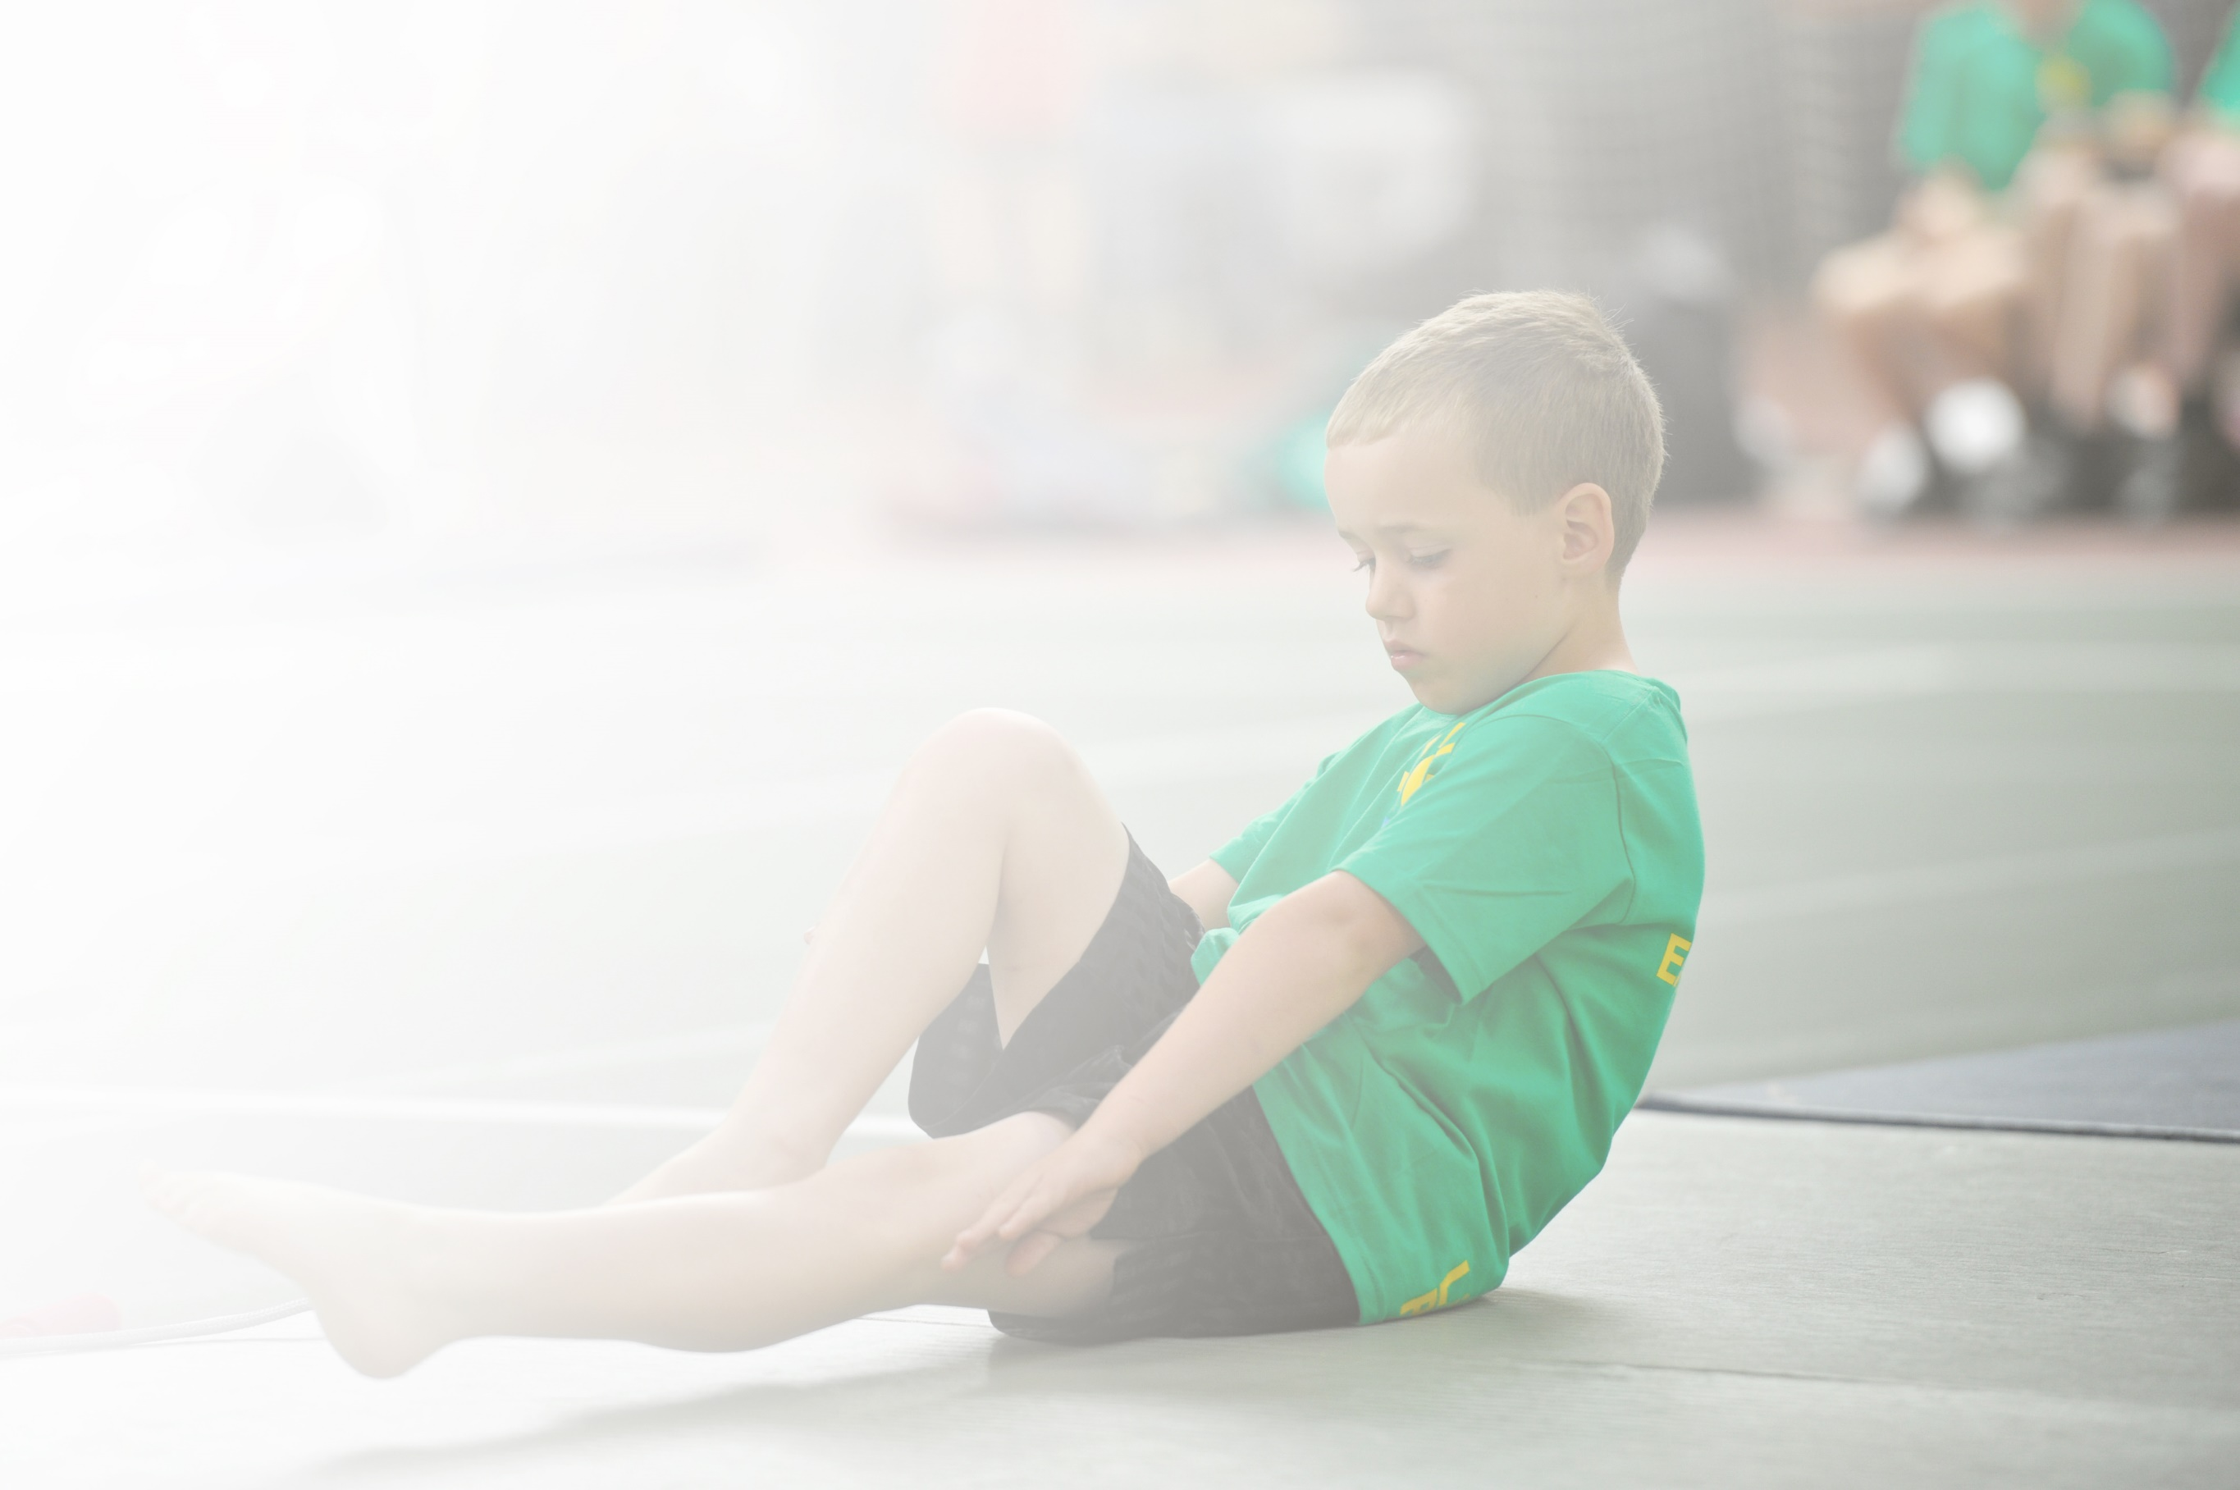
Schools must use the funding to make additional and sustainable improvements to the quality of Physical Education, Sport and Physical Activity (PESPA) they offer. This means that you should use the Primary PE and Sport Premium to:

- Develop or add to the PESPA activities that your school already offer
- Build capacity and capability within the school to ensure that improvements made now will benefit pupils joining the school in future years

Please visit gov.uk for the revised DfE guidance including the 5 key indicators across which schools should demonstrate an improvement. This document will help you to review your provision and to report
your spend. DfE encourages schools to use this template as an effective way of meeting the reporting requirements of the Primary PE and Sport Premium.

We recommend you start by reflecting on the impact of current provision and reviewing the previous
spend. Under the Ofsted Schools Inspection Framework, inspectors will assess how effectively leaders use the Primary PE and Sport Premium and measure its impact on outcomes for pupils, and how effectively governors hold them to account for this.

Schools are required to publish details of how they spend this funding as well as on the impact it has on pupils’ PE and sport participation and attainment by the end of the summer term.
We recommend regularly updating the table and publishing it
on your website throughout the year, as evidence of your
ongoing review into how you are using the money to
secure maximum, sustainable impact. To see an
example of how to complete the table please
click HERE.

Support for review and reflection - considering the 5 key indicators from DfE, what development needs are a priority for your setting and your students now and why? Use the space below to reflect on previous spend, identify current need and priorities for the future.

Key achievements to date: | Areas for further improvement and baseline evidence of need:
A wide and varied PE curriculum that incorporates Nursery to Year 6 children.  Up to date cpd and school wide planning.  Outside agencies used to increase profile of sport – including specialist coaches, outdoor adventure residentials for Key Stage 2 and whole school PE activity days.  All children being encouraged to participate in said events.  Daily classroom activate sessions | Increase in the variety of sports made available to children.  After school physical activity clubs for EYFS  Maintaining cpd on new initiatives  Resources  More linking of PESSPA (physical education, school sport and physical activity) to school development.  Utilising opportunities offered by link Secondary school.

Meeting national curriculum requirements for swimming and water safety | Please complete all of the below:
What percentage of your current Year 6 cohort swim competently, confidently and proficiently over a distance of at least 25 metres?  N.B. Even though your children may swim in another year please report on their attainment on leaving  primary school. | 100%
What percentage of your current Year 6 cohort use a range of strokes effectively [for example, front crawl, backstroke and breaststroke]? | 100%
What percentage of your current Year 6 cohort perform safe self-rescue in different water-based situations? | 100%
Schools can choose to use the Primary PE and Sport Premium to provide additional provision for swimming but this must be for activity over and above the national curriculum requirements. Have you used it in this way? | Yes

Action Plan and Budget Tracking
Capture your intended annual spend against the 5 key indicators. Clarify the success criteria and evidence of impact that you intend to measure to evaluate for students today and for the future.

Academic Year: 2017/18 | Total fund allocated: £12920 | Date Updated: 20 April 2018
Key indicator 1: The engagement of all pupils in regular physical activity – Chief Medical Officer guidelines recommend that primary school children undertake at least 30 minutes of physical activity a day in school |  |  |  | Percentage of total allocation:
 |  |  |  | 6%
School focus with clarity on intended impact on pupils: | Actions to achieve: | Funding allocated: | Evidence and impact: | Sustainability and suggested next steps:
Quality PE delivered across all key stages by trained staff.  New PE kit purchased to ensure all new starters have a uniform. | Healthy pupils and an enjoyable activity that brings all the age ranges together  Improved concentration and achievement of pupils.  All children have a new PE kit when they join the school. | £734  Total : £734 | Daily mile  More focus in morning  Whole school activity  Improved fitness in children and staff  Parental involvement  Used by external groups at weekends  Shorts, T-shirts and Leotards purchased for children | Permanent feature of school  More promotion in local area  .Children all wear the same PE kit to show uniformity.
Key indicator 2: The profile of PESSPA being raised across the school as a tool for whole school improvement |  |  |  | Percentage of total allocation:
 |  |  |  | 15%
School focus with clarity on intended impact on pupils: | Actions to achieve: | Funding allocated: | Evidence and impact: | Sustainability and suggested next steps:
Continuing CPD and in-house training of staff by new PE co-ordinator.  Equipment purchased to enable all children to benefit from a worthwhile PE curriculum.  Swimming coaching for all KS 2 children  KS2 PE sessions carried out at Kendal climbing wall. Certificated.  Health and Safety inspections of all equipment to ensure it is fit for purpose | PE delivered twice weekly (2 hours) to all age ranges by all staff. Daily morning run. Class room activate and brain gym activities  New Football equipment and goals  Opportunity for the whole of KS2 to take part in swimming lessons and water safety aspects.  All KS2 children obtaining basic climbing qualifications in weekly sessions at Kendal climbing wall.  Sportsafe to check equipment and recommend improvements. | £46.63  £700  £1100  £48  Total : £1894.63 | PE is taught regularly and is embedded into the timetables and rolling programmes.  All children given opportunities to participate.  Swimming taught for all KS 2 not just Year 6.  Certificate (NICAS) for children  All equipment monitored and updated where necessary | Embedded into rolling programmes and school development plan as an area for focus.  New PE equipment/initiatives actively sought and incorporated.  PE delivered at KCW by qualified staff.  Annual checks of all equipment used in PE and sport.

Key indicator 3: Increased confidence, knowledge and skills of all staff in teaching PE and sport |  |  |  | Percentage of total allocation:
 |  |  |  | 24%
School focus with clarity on intended  impact on pupils: | Actions to achieve: | Funding  allocated: | Evidence and impact: | Sustainability and suggested  next steps:
Continuing CPD and in-house training of staff by new PE co-ordinator.  Training of new PE co-ordinator to ensure PE curriculum is disseminated across the whole school.  Supply costs and training costs and teaching costs.  PE co-ordinator attending local network meetings and training sessions.  Development of Forest Schools through training and development of Forest Schools activities. | To enable all staff to be increasingly confident in delivering a wider range of PE activities.  Quality of PE greatly increased as a result  Children to undertake Forest schools training to develop the initiative across the school | £3041.37 | Children able to take part in much wider ranges of physical activities.  Planning, photos and PE board.  Forest schools accreditation | Continuing CPD to keep in line with new initiatives.  PE coordinator to attend training and lead in house cpd.  Initial sign up to training – to be undertaken next year.
Key indicator 4: Broader experience of a range of sports and activities offered to all pupils |  |  |  | Percentage of total allocation:
 |  |  |  | 49%
School focus with clarity on intended  impact on pupils: | Actions to achieve: | Funding  allocated: | Evidence and impact: | Sustainability and suggested  next steps:
Additional achievements:  Subsidised outdoor adventurous activities in the lake district through Tree Top Nets at Windermere.  Subsidised outdoor adventurous activities in Northumberland at Manor Adventure.  Subsidised outdoor adventurous activities on Ullswater through Glenridding Sailing Centre  Full day whole school Archery delivered by Northern Archery and after school club.  Plus Viking Archery day at Widermere  Whole school bowling and swimming day at Holgates.  KS2 Rugby weekly coaching by KLRUFC | Exposing children to new activities – Tree Top Nets activities.  Children enabled to undertake a weeks residential at Berwick –upon – Tweed.  To challenge children to undertake canoeing and sailing through an external provider. To encourage team work and water skills.  To allow the whole school from Nursery to Year 6 the opportunity to experience archery through an external provider.  Children enabled to spend the day using the bowling and swimming facilities at Holgates.  To enable all children in KS2 rugby training. | £90  £3443  £1000  £1320  £297  £100  £100  Total : £6350 | Photos, website write up/  Children have the opportunity to undertake a range of adventurous activities to develop their confidence, skill bases and team work.  Opportunity to attend a week of adventurous activities on residential.  Series of after school archery activities. | Next steps are a continuation of opportunities provided and a cementing of relationships made.  New activities/ experiences are actively sought.
Key indicator 5: Increased participation in competitive sport |  |  |  | Percentage of total allocation:
 |  |  |  | 7%
School focus with clarity on intended  impact on pupils: | Actions to achieve: | Funding  allocated: | Evidence and impact: | Sustainability and suggested  next steps:
Entry into at least 10 competitive sporting festivals a year that encompasses a very wide range of sporting activities at Dallam.  Entry into Brewery Dance Platform celebration. | To enable participation in competitive sport for all children in Key stage 1 and 2  KS2 children to develop dance and showcase talents in a local celebration. | £810  £90  Total : £900 | All children have had the opportunity to compete and represent the school in one form or other, benefiting in team work and competition.  Dallam timetable, photos, website, certificates, celebrations, noticeboard.  Development of Dance | Continuation of involvement in Dallam PE provision and entry into competitions.  Continued participation in Brewery celebrations.

